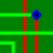
Beginner's «How To ...» Guide © 2019 freepcb.dev

How to adjust the position of the infobox window?
How to change layer color?
How to delete unconnected pins?
How to work with selection mask?
How to add a new part?
How to select a part?
How to move a part?
How to change side?(flip, mirror)
How to draw a copper track(trace) between two pins?
How to add copper area?
How to pour copper area?
How to add board outline?
How to make DRC?
How to export gerber?(for PCB factories)
How to make all the holes the same size?
How to add via?
How to make a layer invisible?
How to change ref or value size?
How to adjust footprints library?
How to sort the footprint libraries alphabetically?
How to add text?
How to create PCB project?
How to unprotect netlist?
How to run Infobox?
How to remove arc-elements of traces or copper areas?
How to use RoundingRect.exe?
How to use DXF export?
How to use BMP import?
How to competently make PCB panelization?
How to make an analysis of FreePcb projects for machines?
How to use Infobox filter?
How to to find the differences in parts list from version to version of project file?
How to to find the differences in pins list from version to version of project file?
How to rotate?
How to route trace? (branch)
How to import netlist?
How to export netlist?

How to adjust the position of the infobox window?
Move the infobox window to the desired position on the screen and click on the parts list with the right mouse button, something like this will appear:
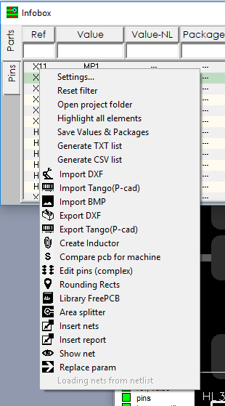
Select "Settings", a window will open, close it. Done!

How to route trace?(branch)
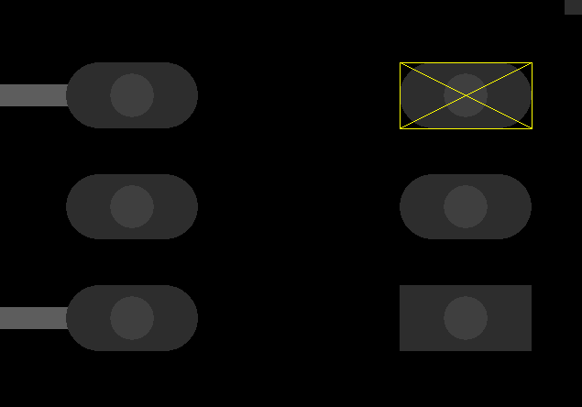
Hit a pin, and click F3 Start_Stub.
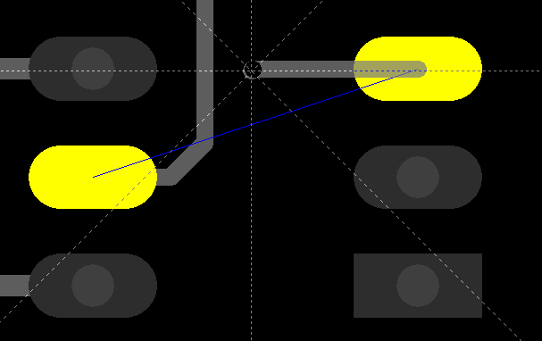
The following softkeys become available.
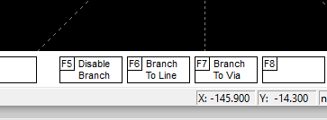
This is three routing mode. When F5_Disable_Branch mode is selected, it is not possible to create a branch to another trace, but trace to another pin can be created. F6 button allows connection to a segment of another trace. F7 button allows connection to a vertex or a via of another trace.
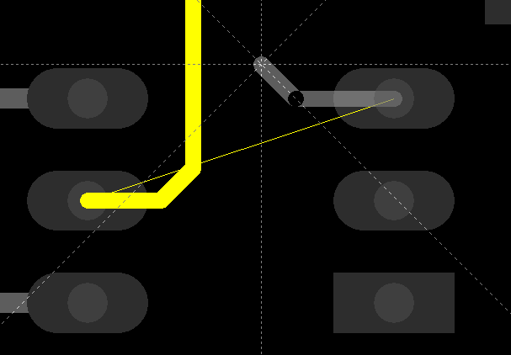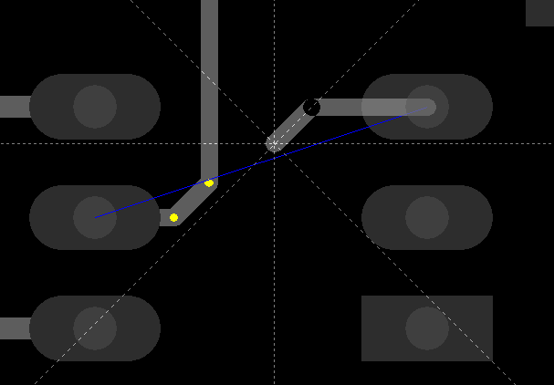
How to change side?
With part selected, click right button and choose change side option.
With group selected, click F3 Change_Side.
How to run Infobox?

How to use Infobox filter?

How to rotate?
With group selected, click F6 Rotate_Mode, will be show next the page of a functional keys for group.
How to unprotect netlist?
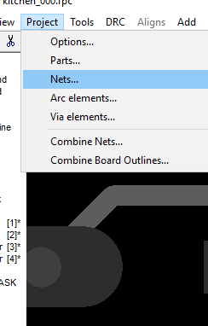
There is an option in the main menu Project→Nets→NetlistProtected (Uncheck this box )
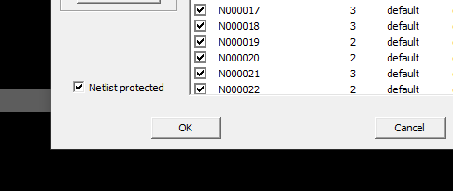
How to add text?
Когда текстовая строка совпадает с именем какой-либо сети то при клике по тексту сеть подсвечивается.
How to create PCB project?

How to adjust footprints library?

How to sort the footprint libraries alphabetically?

How to add via?

How to change ref or value size?

How to make a layer invisible?

How to make all the holes the same size?

How to delete unconnected pins?
Run Infobox with menu Tools→Infobox. Click on the parts list with the right mouse button, and choose settings. Pin nets of pcb must be allowed.
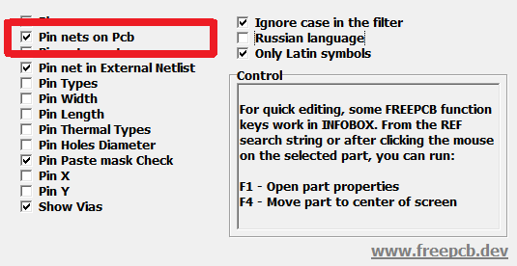
Close the window. Then go to the Pins tab and enter the word unconnected into the Net(PCB) window.
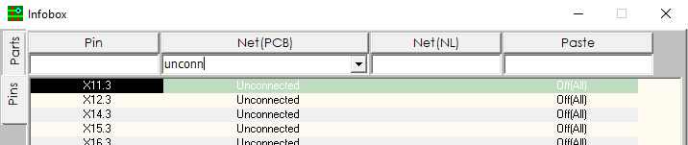
Click on the pins list with the right mouse button, and choose “Edit pins(complex)” application.
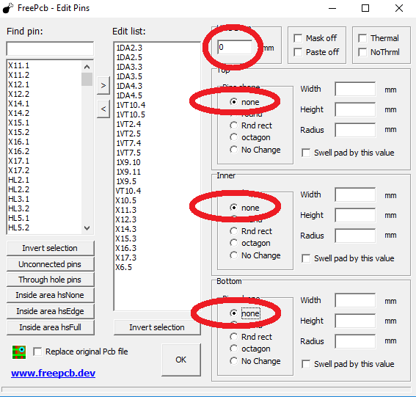
Enter the parameters of the cells as shown in the figure and click OK. All unconnected pins will be removed from the PCB. We filtered out unconnected pins as an example. Similarly, you can make an infobox filter for some other parameters and then change the size of the pads or holes.

How to change layer color?
The color for each layer can be modified by selecting Layers from the View menu, which pops up the View/Edit Layers dialog, as shown below. Click on the buttons in the Edit column to change the colors. You can also change the visibility of layers in this dialog. If you want to use system colors, select this option, while the current colors will be used when opening any project.
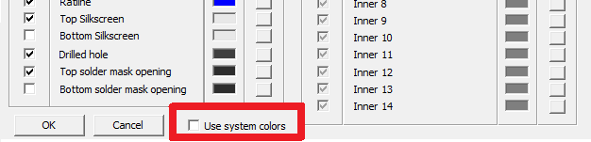
How to work with selection mask?
Items in the layout are selected for editing by clicking on them or drawing a rectangle around them with the mouse. Since items may overlap one another, sometimes it may be difficult to select exactly the item(s) that you want. In this case, the selection mask can be used to enable or disable the selection of different item types. It consists of a list of these types, with a colored box next to each one. A green box means that the item type can be selected, while a red box means that it can't. You can toggle the state of each box by clicking on it.
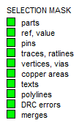
How to add a new part?
Click F1 Add_part
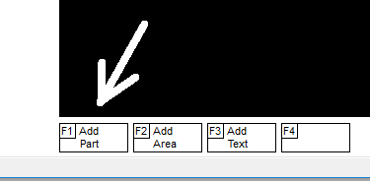
In the part properties dialog box, it is necessary to enter the name of the part in the REF line, and select a footprint from a library, the rest of the options are optional. You can immediately set the position of the part, as well as the side (TOP or BOTTOM) and the angle, for example, 45 degrees. The Package parameter is editable, but keep in mind that if you change it, the change will be applied to all parts using this footprint, because the Package is a property of the footprint, not the part.
How to select a part?
Mouse over a part and left click. If you hit the pin, the pin will be highlighted, since the pin area is less than the area of ​​the part. Need to click again. If there are too many objects, you can use the selection mask on the left side of the screen. Click on the "Parts" line with the control key pressed to invert the mask and allow the selection of parts only.
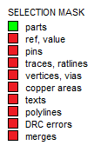
If the part is connected to other parts through the "merge" property, the merge will be highlighted. You need to click again or prohibit the "merge" in the selection mask.
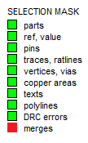
How to move a part?
With part selected, press F4 to begin moving it.
In move mode, you can:
F1- change side parts,
F2- rotate -90 degrees,
F3- rotate +90 degrees,
F4- recalculate ratlines,
F5- unroute all segments of pins to the vias,
F6- unroute all traces pins of this part,
F7- lock all pin connections of this part,
F8- unlock all the pin connections for this part,
F9- remove all pin connections of this part in order to reroute
How to draw a copper track between two pins?
Hit a pin, and click F2 Connect_To_Pin, that to start dragging connection.
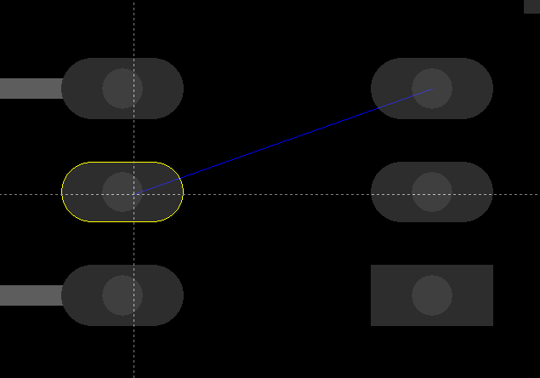
Click on the box to the left, or enter net name manually.
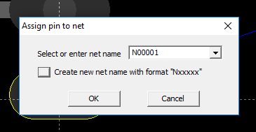
Select segment, then click F4_Route. For routing сompletion click F4_Complete button again.
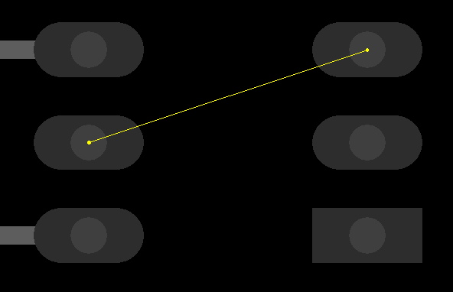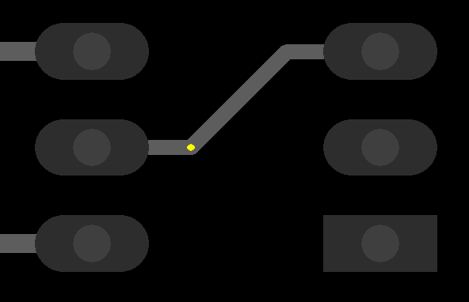
The last vertex will be highlighted. Press F3 to align the segments under 45 degrees. You can reduce angle for alignment by changing edit box “Angle”.
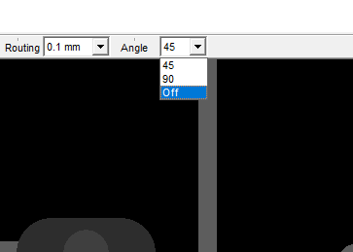
The minimum value 7,5 degrees will be set, if you select OFF.
How to add copper area

How to pour copper area

How to add board outline?

How to make DRC?

FreePCB has a Design Rule Checker that checks your project for compliance with a set of design rules. Selecting Tools > Design Rule Check pops up the following dialog:

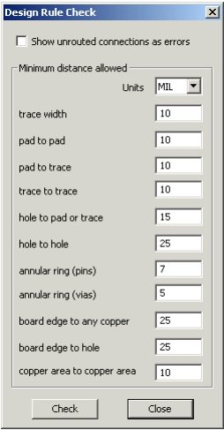

trace width | The minimum trace width allowed
pad to pad | The minimum distance from the edge of one pad to another on a different net (a warning is displayed if the distance is less on same net)
pad to trace | The minimum distance from the edge of a pad to a trace on a different net
trace to trace | The minimum distance from the edge of a trace to a trace on a different net (this is the initial clearance value of the SET_CLEARANCE function)
hole to pad or trace | The minimum distance from the edge of a hole to a pad or trace on a different net (a warning is displayed if the distance is less on same net)
hole to hole | The minimum distance from the edge of a hole to the edge of another hole
annular ring (pins) | The minimum width of copper surrounding a hole for a pin
annular ring (vias) | The minimum width of copper surrounding a hole for a via
board edge to any copper | The minimum clearance between any copper feature and the edge of the board
board edge to hole | The minimum clearance between the edge of a hole and the edge of the board
copper area to copper area | The minimum clearance between copper areas, and also between a copper pour (full hatch pattern) and another object on a different net

How to export gerber?(for PCB factories)

